Rewinding Machines Series

GW-FJ-450A /B Rewinding Machine
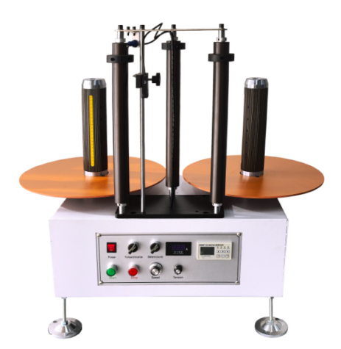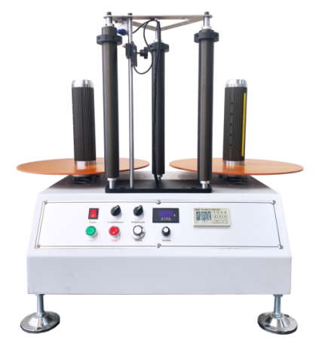
特点：
1、采用品牌电机/减速机，数显调速器，无级变速，确保机器运行稳定。
2、采用计米传感器，可设定米数自动停机。
3、收/放卷卷轴采用气胀轴。
4、采用磁粉张力，张力可调。
5、顺时针旋转调节开关，可从低速缓慢增加到所需速度。
Features：
1. Adopt brand motor/reducer, digital display governor, stepless speed change to ensure stable operation of the machine.
2. Using the meter sensor, you can set the number of meters to automatically stop.
3. The rewinding/unwinding reel adopts an inflatable shaft.
4. Using magnetic powder tension, the tension can be adjusted.
5. Rotate the adjustment switch clockwise to slowly increase from low speed to desired speed.
Main Technical Parameters：
Machine Model | GW-FJ-450A | GW-FJ-450B
Maximum Take-Up/Unwind Diameter | 450 mm | 450 mm
Rewind/Unwinding Diameter | 3 In | 3 In
Rewind/Unwind Reel Height | 300 mm | 300 mm
Speed | 10-40 m/min | 10-40 m/min
Weight Capacity | 20 kg | 30 kg
Power | 120 W | 200W
Power Supply | 220 V | 220 V
Weight | 60 kg | 60 kg
Mechanical Dimensions(L*W*H) | 640*450*680mm | 640*550*680mm

GW-FJ-450D Rewinding Machine
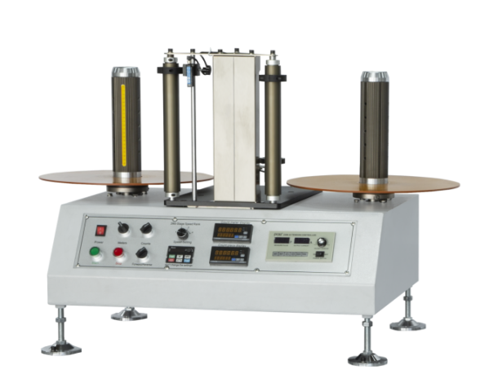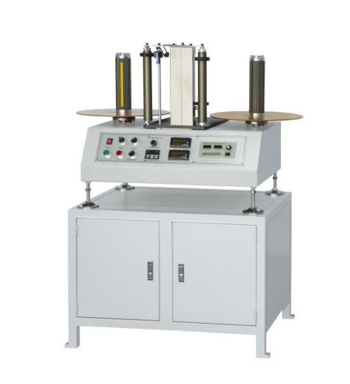
特点：
1、采用品牌电机/减速机，数显调速器，无级变速，确保机器运行稳定。
2、采用计米传感器，可设定米数自动停机。
3、收/放卷卷轴采用气胀轴。
4、采用磁粉张力，张力可调。
5、顺时针旋转调节开关，可从低速缓慢增加到所需速度。
Features：
- Adopt brand motor/reducer, digital display governor, stepless speed change to ensure stable operation of the machine.
- Using the meter sensor, you can set the number of meters to automatically stop.
- The rewinding/unwinding reel adopts an inflatable shaft.
- Using magnetic powder tension, the tension can be adjusted.
- Rotate the adjustment switch clockwise to slowly increase from low speed to desired speed.
Main Technical Parameters：
Machine Mode | GW-FJ-450D
Maximum Take-Up/Unwind Diameter | 450 mm
Rewind/Unwind Reel Diameter | 3In
Rewind/Unwind Reel Height | 300 mm
Speed | 10-40 m/min
Weight Capacity | 30 kg
Power | 200 W
Power Supply | 220 V
Weight | 60 Kg
Mechanical Dimensions(L*W*H) | 640*550*680mm

GW-FJ-450E Rewinding Machine
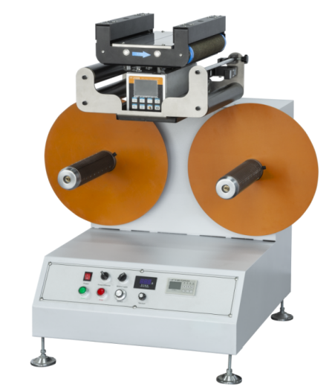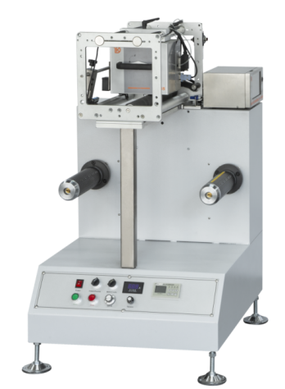
特点：
1、精准定位PLC触摸屏程序控制，全触摸屏操作。
2、可根据不同需求和行业特性，配置不同功能和配置进行选配加装。
3、工作效率高，体积小，可稳定适应电压范围工作。
Features：
- This machine is equipped with precise positioning plc touch screen control, full touch screen operation.
- The characteristics of the business are different, the same needs are sought, the different functions are arranged, the selection is made, and the arrangement is different.
- High work efficiency, small size, flexible and flexible electric machine.
Main Technical Parameters：
Machine Mode | GW-FJ-450E | GW-FJ-450ES
Maximum Take-Up/Unwind Diameter | 450 mm | 450 mm
Rewind/Unwind Reel Diameter | 3 In | 3 In
Rewind/Unwind Reel Height | 300 mm | 300 mm
Speed | 10-40 m/min | 10-40 m/min
Weight Capacity | 30 kg | 30 kg
Power | 200W
Power Supply | 220 V | 220 V
Weight | 60 kg | 60 kg
Mechanical Dimensions(L*W*H) | 640*550*680mm | 640*550*680mm

Automatic Rewinder（With Web Guide)
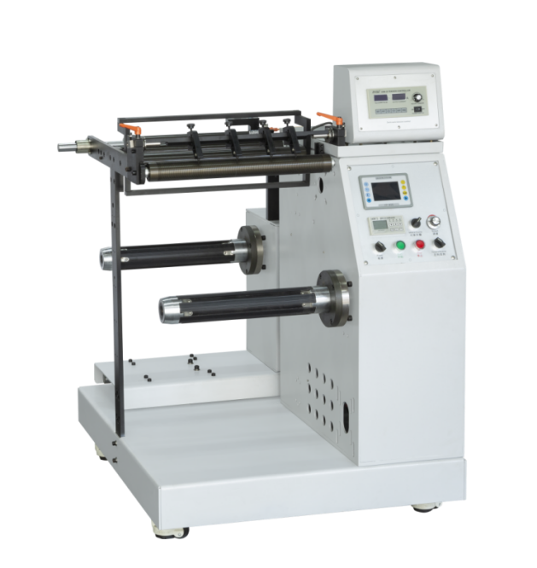
特点：
1、采用直流纠偏控制系统，机器运行平稳、静音、耐用。
2、采用超声波传感器，感应透明材料。
3、采用磁粉制动器，方便控制放卷张力和材料松紧。
4、机器纠偏到极限位置，自动停机并报警。机器无人看管时，机器运行后停机并报警。
Features：
- Adopting the dc correction control system, the machine runs smoothly, quietly and durable.
- Ultrasonic sensors are used to sense transparent materials."
- Using magnetic powder brake, it is convenient to control the unwinding tension and the tightness of the material.
- The machine will automatically stop and give an alarm when the machine is rectified to the limit position. When the machine is unattended, it will stop and give an alarm after the machine is running.
Main Technical Parameters：
Machine Model | GW-FJ-400C
Maximum Paper Width | 400 mm
Weight Capacity | 50 kg
Diameter Of Air Shaft | 3 In
Rewinding/Unwinding Diameter | 650 mm
Power Supply | 220v 1kw
Tension | 0-25 N
Net Weight | 280 kg
Mechanical Dimensions(L*W*H) | 1000*1150*1200mm

GW-FJ-230S Desktop Platform Winder
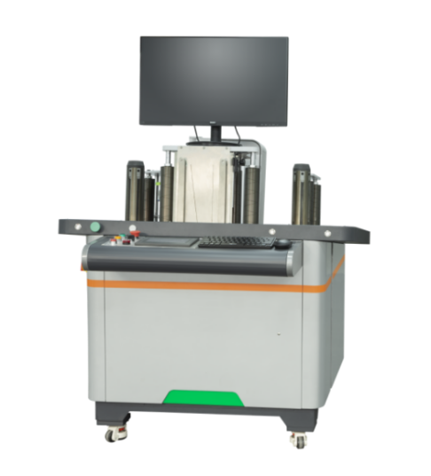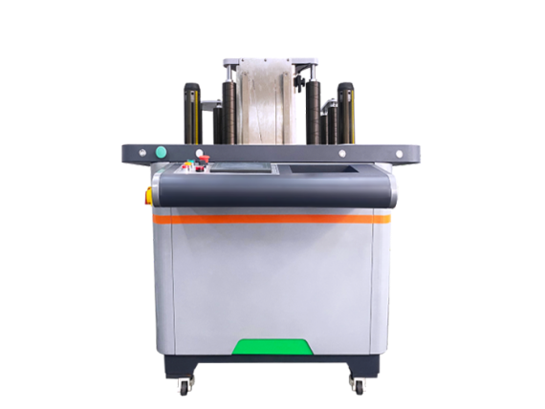
特点：
1、张力系统自动调整参数，确保与实际纸张所需的张力相匹配。
2、机器PLC系统具有计米功能，用于设备视觉检测及停机，方便用户处理不良品。
3、机器触摸屏支持预设米数输出设置，并可根据设定的米数值停机。
Features:
- The tension system automatically adjusts parameters to ensure that it matches the tension required by the actual paper.
- The machine plc system has a meter counting function, which is used for visual inspection and shutdown of the equipment so that users can deal with defective products.
- The machine's touch screen supports preset meter output settings, and can stop the machine according to the set meter value.
Main Technical Parameters：
Machine Model | GW-FJ-230S
Coil Width Range | 20mm～230mm
Maximum Unwinding Diameter | Φ400mm
Maximum Winding Diameter | Φ400mm
Retracting And Unwinding Air Shaft Size | 3 Inches (Standard Configuration Of Φ76mm);
Maximum Detection Speed | 60m/min; Rewinding Speed 120m/min;
Start Acceleration | ≤5s Deceleration Stop Time: ≤2.5s;
Defect Shutdown Accuracy | ±50mm
Winding End Surface Uniformity | ±0.2mm
Unwinding Tension Range | 10~100N (According To Operation Settings)
Unwinding Tension Accuracy | ±5N
Rewinding Tension Range | 10~100N
Winding Tension Accuracy | ±3N
Weight | 300kg
Sizes(L*W*H) | 1250*1200*1200mm

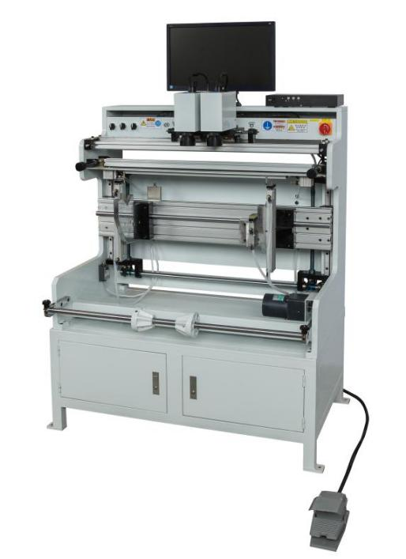
Prepress Equipment Series

Flexo Plate Mounting Machine

特点：
1、机架结构采用墙板结构，经过高强度整体加工，工作稳定性强，经久耐用。
2、650线彩色高清摄像头，放大倍率达70倍，图像清晰，分辩率高，大幅提高制版精度。
3、制版辊升降结构采用减速电机驱动控制，极大地方便了制版操作。
4、整机采用电路集中控制，操作方便，自动化程度较高。
5、19 英寸高分辨率液晶显示屏，图像清晰明亮，有效缓解操作工人的视觉疲劳。
Features：
- The rack construction with the wallboard structure after high-strength holistic processing has great working stability and is durable in use.
- The 650-line color high-definition camera can reach 70-times amplification ratio, present clear images, possess high resolution ratio, and substantially improve the precision of the plate.
- The lifting of plate roller structure adopts the gear motor drive control, which largely facilitates the operations of the plate.
- The complete machine adopts the centralized control of circuits, which is convenient for operations and has relatively high degree of automation.
- The 19-inch high-resolution liquid crystal display provides clear and bright images and effectively alleviates the visual fatigue of operating workers.
Main Technical Parameters：
Model | Roller width（mm） | Roller Perimeter  (mm) | Machine Length（mm） | Machine Width（mm） | Machine Height（mm） | Weight（Kg）
GW-TB-320 | 320 | 800 | 920 | 600 | 1650 | 230
GW-TB-650 | 650 | 800 | 1050 | 600 | 1650 | 270
GW-TB-1000 | 1000 | 1200 | 1500 | 600 | 1650 | 330
GW-TB-1200 | 1200 | 1200 | 1700 | 600 | 1650 | 370
GW-TB-1300 | 1300 | 1200 | 1800 | 700 | 1650 | 420
GW-TB-1500 | 1500 | 1200 | 2100 | 700 | 1650 | 450
GW-TB-1800 | 1800 | 1200 | 2400 | 700 | 1650 | 500
According to customer requirements customize different specifications.

High Type Plate Mounting Machine
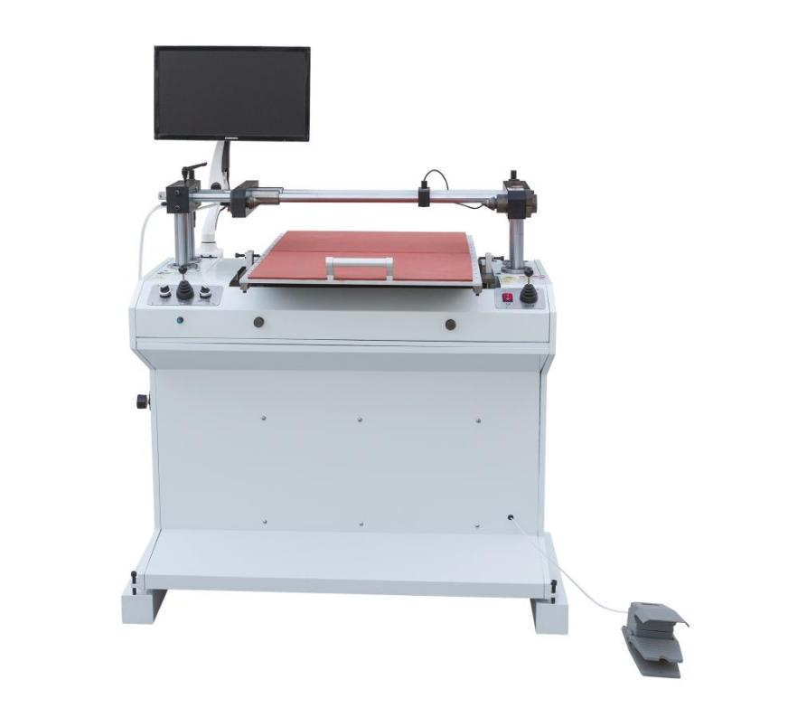
特点：
1、整体结构坚固，稳定性强，经久耐用。
2、650线彩色高清摄像头，放大倍率可达70倍，图像清晰，分辨率高，大大提高了安装板的精度。
3、显微摄像机的升降由减速电机控制，安装板安装方便。
4、六个调节器可完美安装和调节平板，轻松实现平板的滚动安装。
5、19英寸高分辨率液晶显示屏，图像清晰明亮，有效缓解操作人员的视觉疲劳。
Features：
- The whole strong structure provides great stability and durable in use.
- The 650-line color high-definition camera can reach 70 times amplification ratio, present clear images, possess high resolution ratio,greatly improve the precision of mounting plate.
- The lifting of microscopic camera is controlled by the gear motor for conveniently mounting plate.
- Six adjusters to perfectly mount and adjust plate,easily mounting plate in rolling way.
- The 19-inch high-resolution liquid crystal display provides clear and bright images and effectively alleviates the visual fatigue of operating workers.
Main Technical Parameters
Model | Roller width（mm） | Roller Perimeter  (mm) | Machine Length（mm） | Machine Width（mm） | Machine Height（mm） | Weight（Kg）
GW-TB-470 | 580 | 600 | 1100 | 880 | 1500 | 230
According to customer requirements customize different specifications.

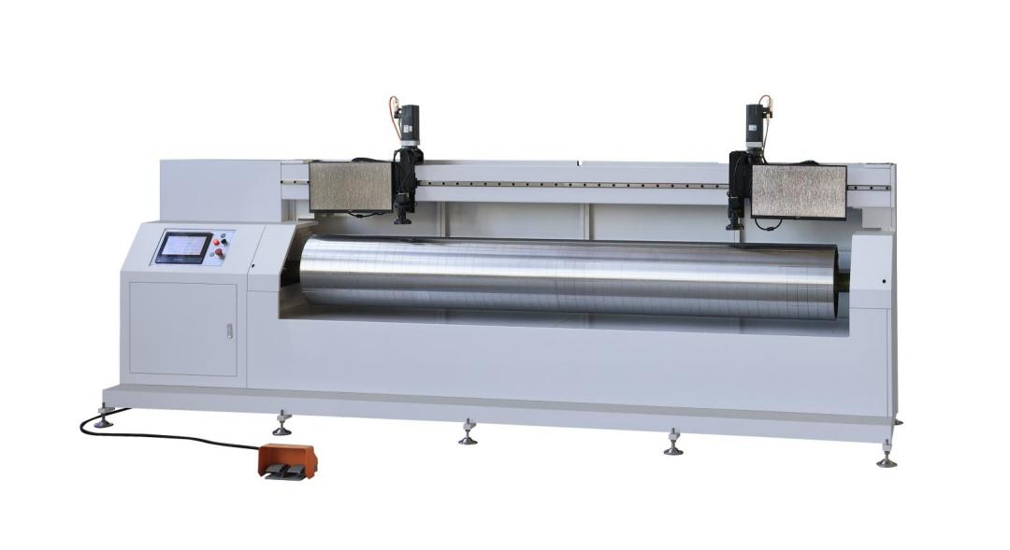

Servo Type Plate Mounter

特点：
1、采用进口精密直线导轨和伺服电机，用于相机的左右移动。
2、进口伺服电机驱动印刷滚筒/滚筒定位。
3、安装好印版后，可检查其精度。
4、液晶触摸显示屏，易于控制和操作。
5、整体结构坚固，稳定性高，经久耐，650线彩色高清摄像头，放大倍率可达70倍。
6、图像清晰，分辨率高，大大提高了安装板的精度。
7、19英寸高分辨率液晶显示屏，图像清晰明亮，有效缓解操作人员的视觉疲劳。
Features:
- Applying imported precision linear guide and servo motor are used to move the cameras right and left.
- Imported servo motor are to drive and position the printing roller/ cylinder.
- After mounting the plate, you can check the accuracy of it.
- Liquid crystal touchable display to easily control and operate.
- The whole strong structure provides great stability and durable in use,the 650-line color high-definition camera can reach 70 times amplification ratio;
- Present clear images; possess high resolution ratio; greatly improve the precision of mounting plate，
- The 19-inch high-resolution liquid crystal display provides clear and bright images ,and effectively alleviates the visual fatigue of operating workers.
Main Technical Parameters：
Model | Roller width（mm） | Roller Perimeter  (mm) | Machine Length（mm） | Machine Width（mm） | Machine Height（mm） | Weight（Kg）
GW-TB-1600 | 1600 | 2000 | 2750 | 1050 | 1850 | 600
GW-TB-2000 | 2000 | 2000 | 3150 | 1050 | 1850 | 650
GW-TB-2500 | 2500 | 2000 | 3550 | 1050 | 1850 | 700
According to customer requirements customize different specifications.

Flexo Plate Making Machine
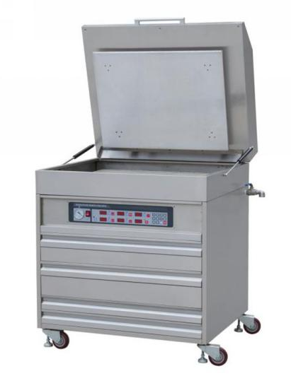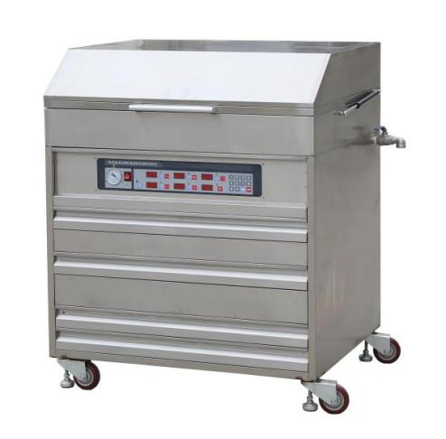
特点：
- 进口原装进口专用晒版灯和镇流器（变频式对制版非常有利）。
- 全自动洗版机构，恒温烘干，贯流风机吹力强、烘干快。
3、进口漫反射紫外线抽气膜。
4、采用进口的数字集成温度传感器。
5、去粘采用进口专用UVC光源。
Features：
- Imported original imported special plate-exposure lamp and ballast (frequency conversion is very beneficial for plate making).
- Fully automatic plate washing mechanism, constant temperature drying, strong cross-flow fan blowing force and fast drying.
- Imported diffuse reflection ultraviolet exhaust film.
- Imported digital integrated temperature sensor.
- Imported special UVC light source is used for debonding.
Main Technical Parameters：
Model | Printer Area | Measurement（W*D*H） | Power
GW-ZB-400 | 430*320mm | 710*610*1050mm | 2.2kw
GW-ZB-600 | 600*400mm | 860*710*1050mm | 2.3kw
GW-ZB-800 | 800*600mm | 1090*910*1150mm | 3.5kw
GW-ZB-900 | 900*600mm | 1190*910*1150mm | 3.7kw
GW-ZB-1000 | 1000*600mm | 1290*910*1150mm | 3.8kw
GW-ZB-1200 | 1200*600mm | 1490*910*1190mm | 3.9kw
GW-ZB-1209 | 1200*900mm | 1490*1210*1190mm | 4.1kw
GW-ZB-1210 | 1200*1000mm | 1490*1310*1190mm | 4.2kw

Special Order With Special Size

Series Resin Plate Making Machine
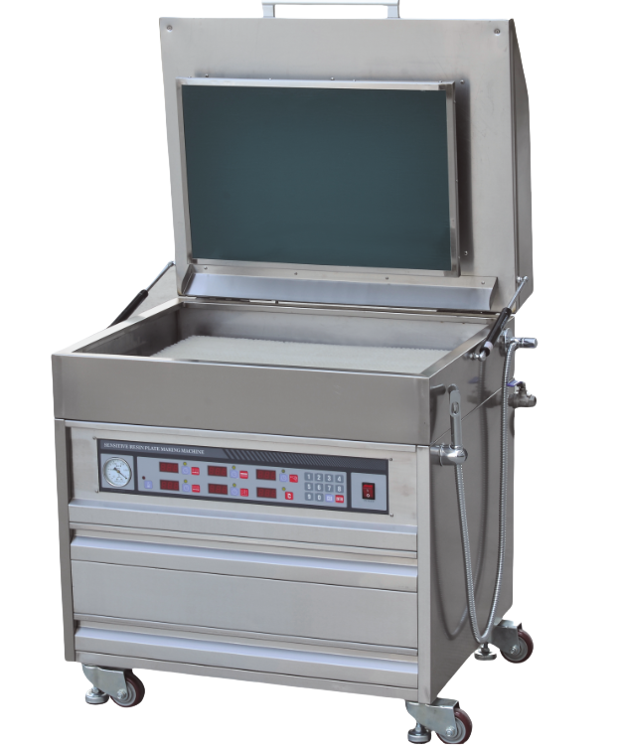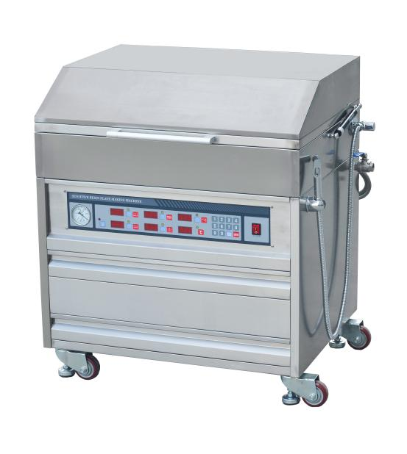
特点：
- 进口原装进口专用晒版灯和镇流器（变频式对制版非常有利）。
- 全自动洗版机构。恒温烘干，贯流风机吹力强、烘干快。
- 进口漫反射紫外线抽气膜。
- 采用进口的数字集成温度传感器。
- 去粘采用进口专用UVC光源。
Features：
- Imported original imported special plate-exposure lamp and ballast (frequency conversion is very beneficial for plate making).
- Fully automatic plate washing mechanism, constant temperature drying, strong cross-flow fan blowing force and fast drying.
- Imported diffuse reflection ultraviolet exhaust film.
- Imported digital integrated temperature sensor.
- Imported special UVC light source is used for debonding.
Main Technical Parameters：
Model | Printer Area | Measurement（W*D*H） | Power
GW-ZB-A4 | 430*255mm | 710*550*1050mm | 2.2kw
GW-ZB-400 | 430*300mm | 710*600*1050mm | 2.3kw
GW-ZB-600 | 600*400mm | 860*710*1050mm | 2.6kw
GW-ZB-800 | 800*600mm | 1090*910*1150mm | 3.5kw
GW-ZB-900 | 900*600mm | 1190*910*1150mm | 3.7kw
GW-ZB-1000 | 1000*600mm | 1290*910*1150mm | 3.9kw
According to customer requirements customize different specifications.

Exposure And Stickness Removing Machine
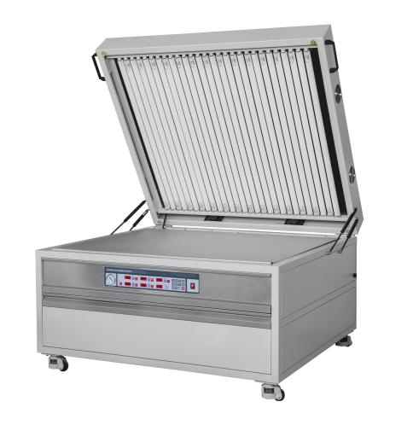
特点：
1、本机集曝光和防粘功能于一体。
2、独特的电气分离结构，避免臭氧腐蚀。
3、翻转操作简单，方便制版。
Features：
- The machine integrates exposure and anti-adhesive function.
- Unique electrical separation structure, avoiding ozone corrosion.
- Flip operation is simple and convenient for plate production.

Main Technical Parameters：
Model | Printer Area(mm) | Measurement:w*d*h(mm) | Power(kw) | Weight(kg)
GW-WD-1280 | 1200*800 | 1370*1010*850 | 2.3 | 330
GW-WD-1210 | 1200*1000 | 1370*1210*850 | 2.6 | 365
GW-WD-1590 | 1500*900 | 1730*1150*850 | 3.0 | 400
GW-WD-1612 | 1600*1200 | 1890*1460*900 | 4.2 | 495
GW-WD-2012 | 2000*1200 | 2320*1450*950 | 5.5 | 707

Washing And Drying Machine
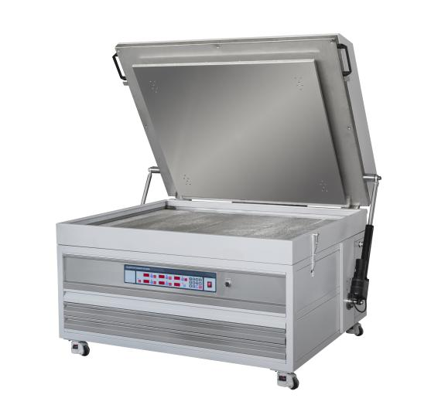
特点：
1、整机采用不锈钢外壳，集洗涤、烘干于一体。
2、洗涤顺畅，方便实用。
3、烘干及时，烘干均匀。
Features：
- The whole machine adopts stainless steel shell, integrates washing and drying into one machine.
- Smooth washing, convenient and practical.
- Timely drying,uniform drying.
Main Technical Parameters：
Model | Printer Area(mm) | Measurement:w*d*h(mm) | Power(kw) | Weight(kg)
GW-WD-1280 | 1200*800 | 1370*1010*850 | 3.3 | 390
GW-WD-1210 | 1200*1000 | 1370*1210*850 | 3.5 | 420
GW-WD-1590 | 1500*900 | 1730*1150*850 | 4.7 | 457
GW-WD-1612 | 1600*1200 | 1890*1260*900 | 4.9 | 525
GW-WD-2012 | 2000*1000 | 2320*1450*950 | 6.7 | 737

Anilox Roller Cleaning Machine
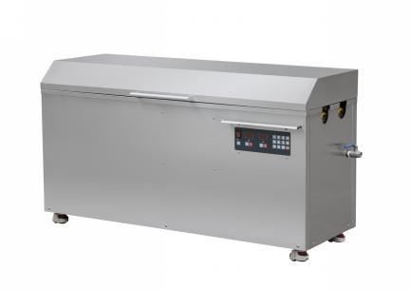
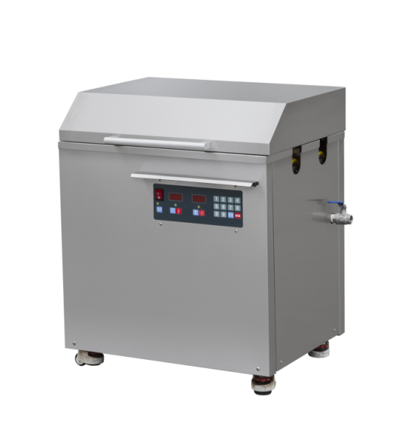
特点：
1.本机体积小巧，且容易操作。稳定可靠，清洁彻底。
2.带有加热配恒温系统 ，附有滚筒旋转轮。
3.防水性能大大改进，产品持久安全
Features：
- This machine is small and easy to operate. Stable and reliable, cleans thoroughly.
- It has a heating and constant temperature system and a drum rotating wheel.
- The waterproof performance is greatly improved, and the product is durable and safe.
Main Technical Parameters：
Model | Vibrator Number | Ultrasonic Power  （W） | Ultrasonic Frequency （khz） | Heat  Power（W） | Washing N0.  （pcs） | Roller  Length（mm） | Temperature  （℃） | Power  （V）
GW-QX-320 | 16 | 960 | 40 | 1000 | 2 | 0-350 | 20-100 | 220
GW-QX-450 | 18 | 1080 | 40 | 1000 | 2 | 0-450 | 20-100 | 220
GW-QX-650 | 24 | 1440 | 40 | 1000 | 2 | 0-660 | 20-100 | 220
GW-QX-850 | 27 | 1620 | 40 | 2000 | 2 | 0-860 | 20-100 | 220
GW-QX-1000 | 33 | 1980 | 40 | 2000 | 2 | 0-1060 | 20-100 | 220
GW-QX-1200 | 39 | 2340 | 40 | 2000 | 2 | 0-1280 | 20-100 | 220
GW-QX-1300 | 42 | 2520 | 40 | 2000 | 2 | 0-1360 | 20-100 | 220
GW-QX-1500 | 48 | 2880 | 40 | 3000 | 2 | 0-1560 | 20-100 | 220
GW-QX-1800 | 60 | 3600 | 40 | 3000 | 2 | 0-1860 | 20-100 | 220
According to customer requirements customize different specifications.

Double-Sink Ultrasonic Anilox Roller Cleaning Machine
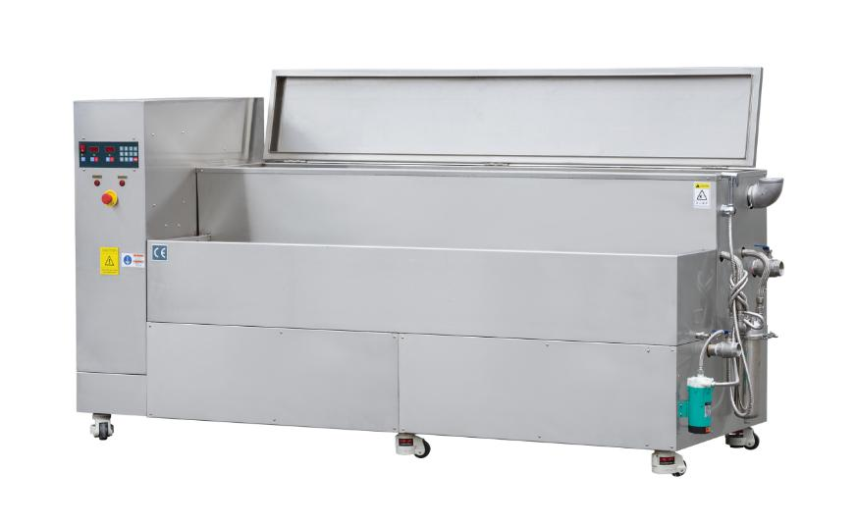
特点：
1、机器稳定可靠，清洁彻底，大功率清洗效果显著。
2、附有滚筒旋转轮，活动可调节高度脚轮，压缩空气喷头。
3、带有加热配恒温系统，废气排风接口。
4、机器上带有花洒，自来水循环装置。
Features：
- The machine is stable and reliable, cleans thoroughly, and has a significant high-power cleaning effect.
- Equipped with a drum rotating wheel, movable and adjustable height casters, and a compressed air nozzle.
- Equipped with a heating and constant temperature system, and an exhaust air outlet.
- The machine is equipped with a shower and a tap water circulation device.
Main Technical Parameters：
Model | Vibrator Number | Ultrasonic Power  （W） | Ultrasonic Frequency （khz） | Heat  Power（W） | Sink Length（mm） | Temperature  （℃） | Power  （V）
GW-QX-650 | 18 | 1080 | 40 | 1000 | 650 | 20-80 | 220
GW-QX-1000 | 30 | 1800 | 40 | 2000 | 1000 | 20-80 | 220
GW-QX-1600 | 48 | 2880 | 40 | 3000 | 1500 | 20-80 | 220
GW-QX-2000 | 60 | 3600 | 40 | 3000 | 2000 | 20-80 | 220
GW-QX-2500 | 75 | 4500 | 40 | 3000 | 2500 | 20-80 | 220
According to customer requirements customize different specifications.

Plate Washing Machine
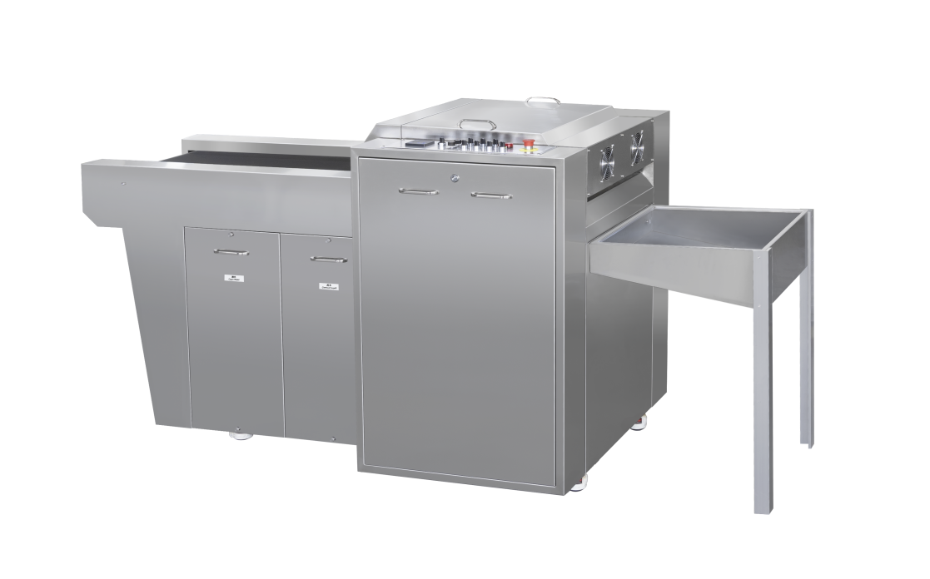

特点：
1、本机以温和的方式清洗凸版印刷中的印版，可达到100 %清洁、干燥的效果，可立即使用。
2、洗涤和漂洗系列提供自动的两阶段清洗过程，第一阶段是清洗液清洗，第二阶段是清水漂洗。同时液体带有循环过滤功能
3、特殊制造的柔软毛刷和专用清洁液的独特组合，确保了高效且温和的印版清洗过程。
Features：
- This machine cleans the plates used in letterpress printing in a gentle way, achieving a 100% clean, dry and ready-to-use result.
- The washing and rinsing series provides an automatic two-stage cleaning process, the first stage is cleaning with cleaning fluid, the second stage is rinsing with clean water. At the same time, the liquid has a circulating filter function
- The unique combination of specially manufactured soft brushes and special cleaning fluids ensures an efficient and gentle plate cleaning process.
Main Technical Parameters：
Model | GW-XB-450 | GW-XB-650 | GW-XB-1050 | GW-XB-1350
Max Plate Length(mm) | 450 | 650 | 1050 | 1350
Machine Dimension(mm) | 2350*1100*1150 | 3370*1350*1150 | 3900*1500*1150 | 5050*1920*1150
Voltage | 220V | 220V | 220V | 220V
According to customer requirements customize different specifications.

